**Brandlytics**

Submitted in partial fulfillment of the requirements of the degree

**BACHELOR OF ENGINEERING** IN **COMPUTER ENGINEERING**

By

**Chirag Mahajan – 1902088**

**Aniket More – 1902103**

**Shyren More - 1902104**

Supervisor

**Dr. Jayant Gadge**

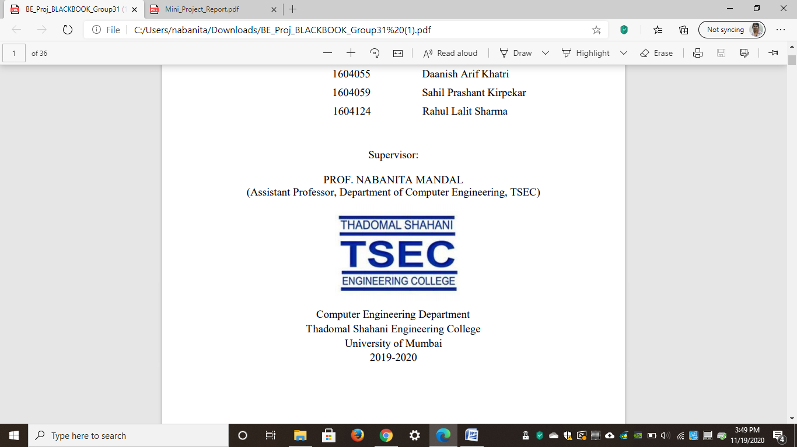

**Computer Engineering Department**

**Thadomal Shahani Engineering College**

**Bandra(w), Mumbai - 400 050**

**University of Mumbai**

**(AY 2020-21)**

# CERTIFICATE

This is to certify that the Mini Project entitled **“ Brandlytics ”** is a bonafide work of **Chirag Mahajan (1902088), Aniket More (1902103), Shyren More(1902103)** submitted to the University of Mumbai in partial fulfillment of the requirement for the award of the degree of **“Bachelor of Engineering”** in **“Computer Engineering” Work**

#### (Dr. Jayant Gadge)

Supervisor

#### (Dr. Tanuja Sarode ) (Dr. G.T.Thampi)

Head of Department Principal

# Mini Project Approval

This Mini Project entitled “**Brandlytics”** by **Chirag Mahajan (1902088), Aniket More (1902103), Shyren More(1902103)** is approved for the degree of **Bachelor of Engineering** in **Computer Engineering.**

**Examiners**

**1………………………………………**

(Internal Examiner Name & Sign)

#### 2…………………………………………

(External Examiner name & Sign)

Date:

Place:

# Contents

#### Abstract

#### Acknowledgments

#### List of Figures

#### Introduction 1

* 1. Introduction
  2. Motivation
  3. Problem Statement & Objectives
  4. Organization of the Report

1. **Literature Survey 3**
   1. Survey of Existing System
   2. Limitation Existing system or research gap
   3. Mini Project Contribution

#### Proposed System (eg New Approach of Data Summarization) 6

* 1. Introduction
  2. Architecture/ Framework
  3. Algorithm and Process Design
  4. Details of Hardware & Software
  5. Experiment and Results
  6. Conclusion and Future Work.

**References 14**

# Abstract

# Traditionally, to know more about product and brand recognition, customer loyalty, customer satisfaction, advertising and promotion success, product acceptance, companies had to conduct surveys, experiment with different avenues. To ease the process, an application can be developed which analyses the sentiment by giving the search term or individual tweets as input.

# The project aims to help marketing teams market their product effectively by analysing the platform’s results. To accomplish this task, the project incorporates the use of Machine learning specifically Natural Language Processing to analyse and visualize the sentiment.

# List of figures

3.2.1 Block Diagram

3.2.2 ER Diagram

3.2.3 User Flow diagram

3.5.1 Landing page

3.5.2 Login page

3.5.3 Sign up page

# Acknowledgement

We would like to express our gratitude and thanks to **Dr. Jayant Gadge** for her valuable guidance and help. We are indebted for her guidance and constant supervision as well as for providing necessary information regarding the project. We would like to express our greatest appreciation to our principal **Dr. G.T. Thampi** and the head of the department **Dr. Tanuja Sarode** for their encouragement and tremendous support. We take this opportunity to express our gratitude to the people who have been instrumental in the successful completion of the project.

Chirag Mahajan

Aniket More

Shyren More

# Chapter 1

## Introduction

This chapter explains the aim, objectives, and scope of the proposed system.

### Introduction

Brandlytics is a web app that can be used to analyze users’ sentiments across Twitter hashtags/terms. It is created using React.js and FastAPI which incorporates Logistic regression and text classification. The modal is trained on Kaggle dataset[1] and served as a REST API to React.js front-end.

### Motivation

* To bridge the gap between voice of customer and the company.
* To build a tool that helps in Brand reputation management
* Provide users with a graphical user interface to easily analyze the results.

### Problem Statement & Objectives

Problem statement:

* Traditionally, to know more about product and brand recognition, customer loyalty, customer satisfaction, advertising and promotion success, product acceptance, companies had to conduct surveys, experiment with different avenues. To ease these process, an application needs to be developed which analyses the sentiment by giving the search term or individual tweets as input.
* The project aims to help marketing teams market their product effectively by analysing the platform’s results. To accomplish this task, the project incorporates the use of Machine learning specifically Natural Language Processing to analyse and visualize the sentiment.

Objectives: To design and develop an efficient and responsive application with the following features:

* To give filtered results based on weekly and day wise sentiment in the form of date range.
* To give specific results in a numeric format (%), visualised through charts for effective understanding.
* To provide a method of downloading the results for personal usage or analysis.
* To save a specific search term and its analysis for future review.

### Organization of the Report

This report consists of three chapters. The first chapter deals with introduction of the topic, problem statement, motivation behind the topic and objectives. The second chapter is the Literature Survey. It includes all the research work done related to this topic. All information related to study of existing systems as well as the learning of new tools is mentioned in this chapter. The third chapter is about the proposed system which is used in this project. The block diagram, techniques used, hardware and software used screenshots of the project are presented in this chapter. All the documents related to the development of this project are mentioned in the Reference

# Chapter 2

## Literature Survey

This chapter explains the concepts used in this project, a study of the existing system and contribution of this project

### Survey of Existing System

Following are some of the popular Web applications having similar features:

1. [1]Talkwalker: Talkwalker's "Quick Search" is a sentiment analysis tool that's part of a larger customer service platform. Quick Search looks at your mentions, comments, engagements, and other data to provide your team with an extensive breakdown of how customers are responding to your social media activity.
2. [2]Repustate: Repustate has a sophisticated text-analysis API that accurately assesses the sentiment behind customer responses. Its software can pick up on short-form text and slang. Repustate tells you if that's a positive or negative symbol based on what it finds in the rest of the conversation.
3. [3]Lexalytics: Lexalytics offers a text-analysis tool that's focused on explaining why a customer is responding to your business in a certain way.  Lexalytics concludes the process by compiling the information it derives into an easy-to-read and shareable display.

### Limitation of the existing system

While most sentiment analysis tools tell you*how*customers feel, Brandlytics differentiates itself by telling you *why*customers feel the way that they do. The other shortcomings of the above-mentioned applications are

1. Most systems are proprietary
2. Few of them lack accessibility

### Mini Project Contribution

* As mentioned in sections 1.3 and 2.2, Brandlytics provides many features making it a robust tool for analysing sentiments
* Brandlytics is built on React.js which helps in making the application scalable
* Brandlytics is completely free and supports the spirit of open-source
* The application also provides a user-friendly UI so users can get a seamless experience while understanding the analysis
* For organizing tweets based on time period, the platform also provides features to view results for a specific week, for a specific month.

**Responsibility of individual members**:

* Chirag Mahajan:

- Design and developed goals page

- Assisted in creating a landing page

- Design and developed timer

- Tested the website on different browsers

* Aniket More

- Worked on the backend of project and database design

- Developed and implemented REST APIs

- Implemented global state management

- Created custom hooks in react-app

- Integrated front-end & back-end

- Reduced loading time via caching

* Shyren More:

- Design and developed landing page & auth pages

- Fetched info from third party API and displayed it in articles

- Implemented reminder component

- Design and implement notes page

- Developed Navbar and Footer components

# Chapter 3

## Proposed System

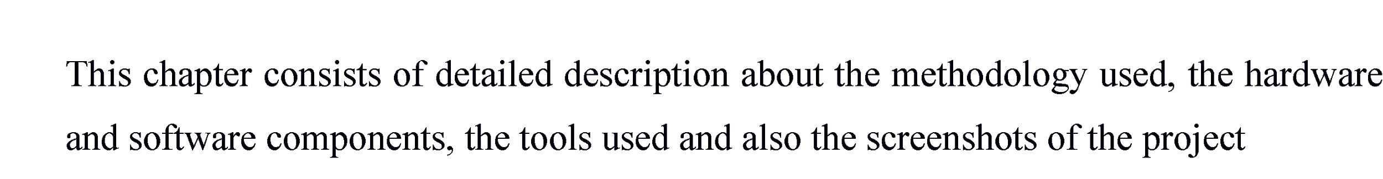

### Introduction

Technologies used in developing the application

Front-end: React.js, HTML, CSS, React-query, Reactstrap

Back-end: MongoDB, TypeScript, Express.js, Node.js

Machine Learning Model: Python, pickle, NLTK

### Architecture

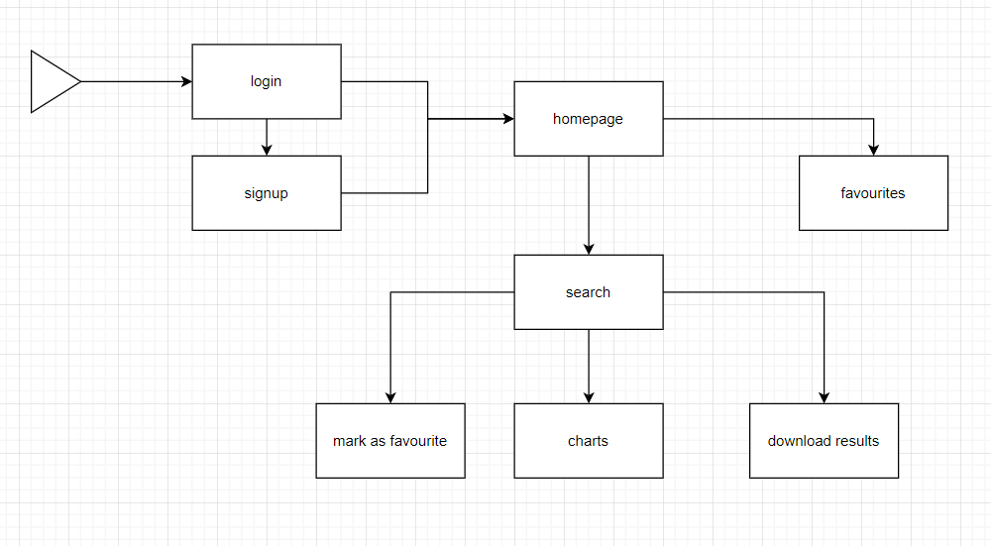

**3.2.1 Block diagram**

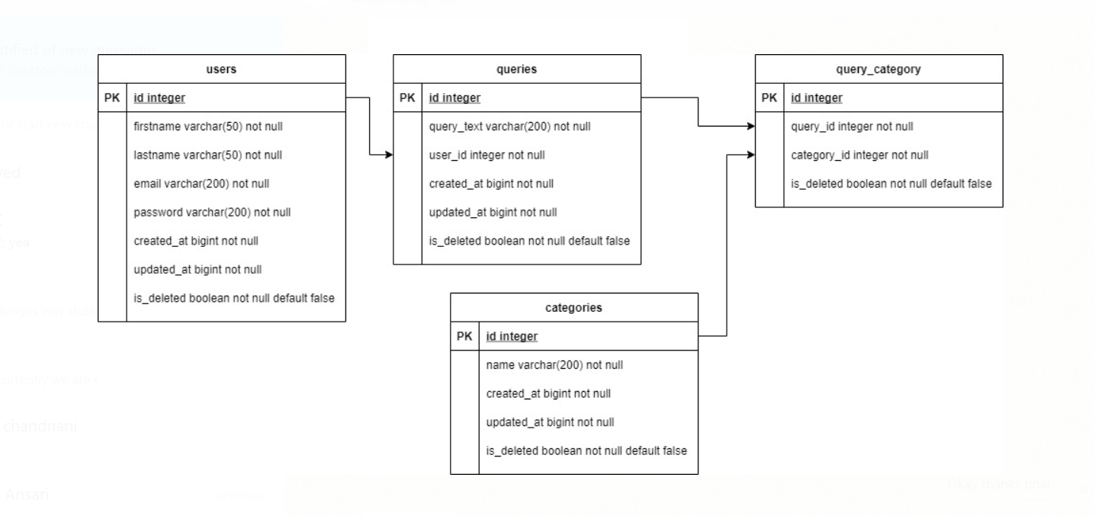

**3.2.2 ER diagram**

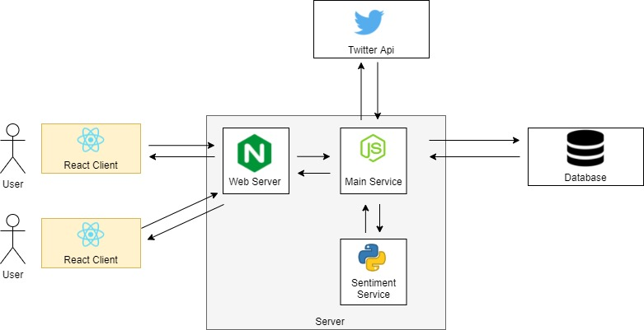

**3.2.3 User-flow diagram**

The Fig 3.2.1 shows the user flow of the project. The user logs into the website and then is redirected to homepage, in this page user can enter a particular tweet and hashtag.

After getting results on homepage, the user will see charts regarding the results, mark as favorite feature to mark a specific item. The user can also download the results. Apart from homepage, there is favorites page where the user can see listing of tweets and hashtags that had been added as favorite.

### Algorithm and Process Design

1. Formulating the Problem statement: Concerning section 2.1, the problem statement was formulated after extensive research about existing alternative systems
2. Understanding the framework and requirements: To build a scalable system React.js is used on the front-end side and Node.js on the back-end.
3. Development: The front-end, back-end and machine learning model of the web application was developed independently after a discussion of the APIs that are made
4. Testing: The machine learning algorithm has been trained on 1.6 Million tweets [4]Kaggle dataset through Logistic Regression with an accuracy of 82 percent. The web application has been tested on various browsers and Google Lighthouse.

### Details of Hardware & Software

All you need is an internet browser and a stable internet connection. It is advisable to have GPU on your system to get results quickly.

### Results

**Fig 3.5.1 Landing page**: The landing page gives an overview of the features

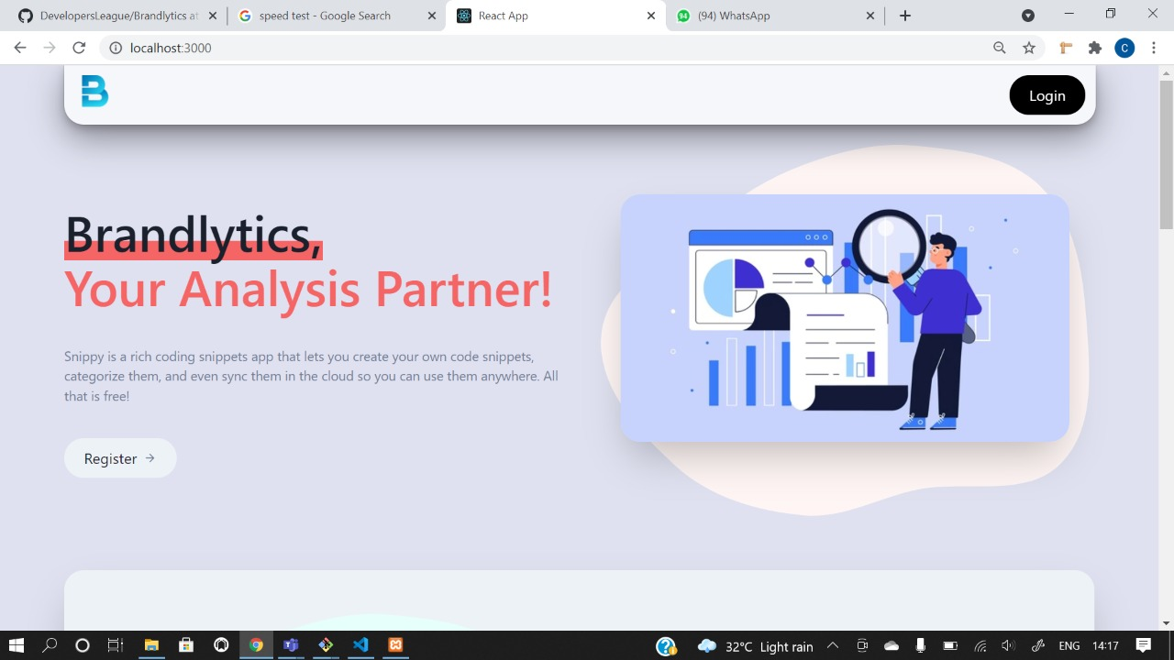

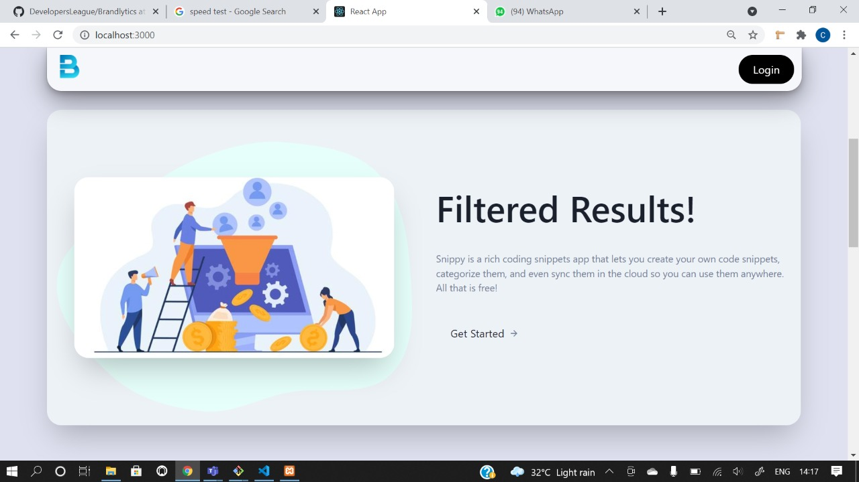

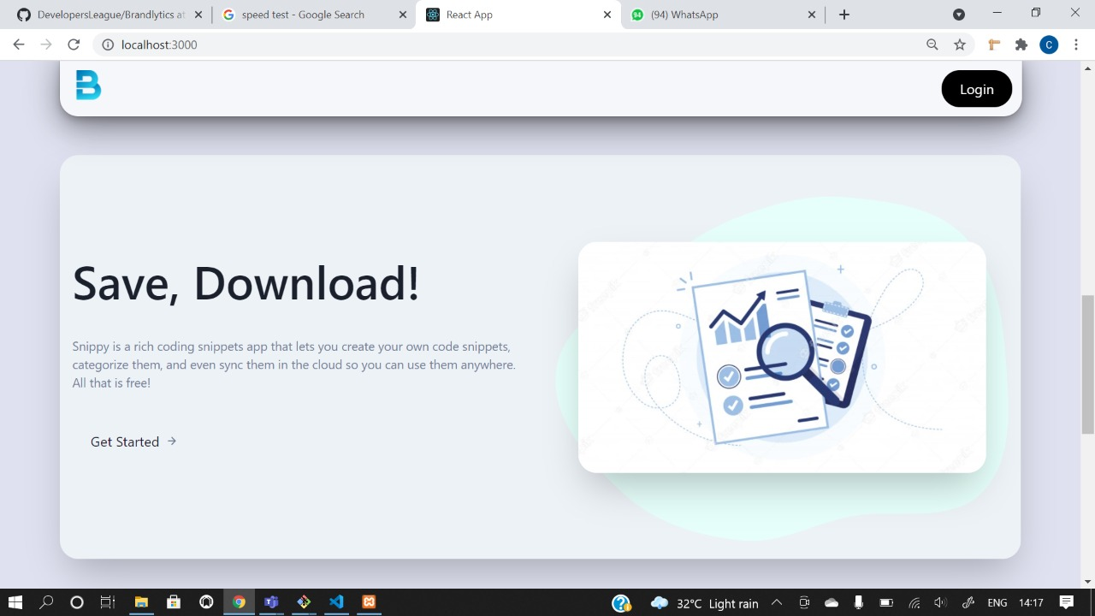

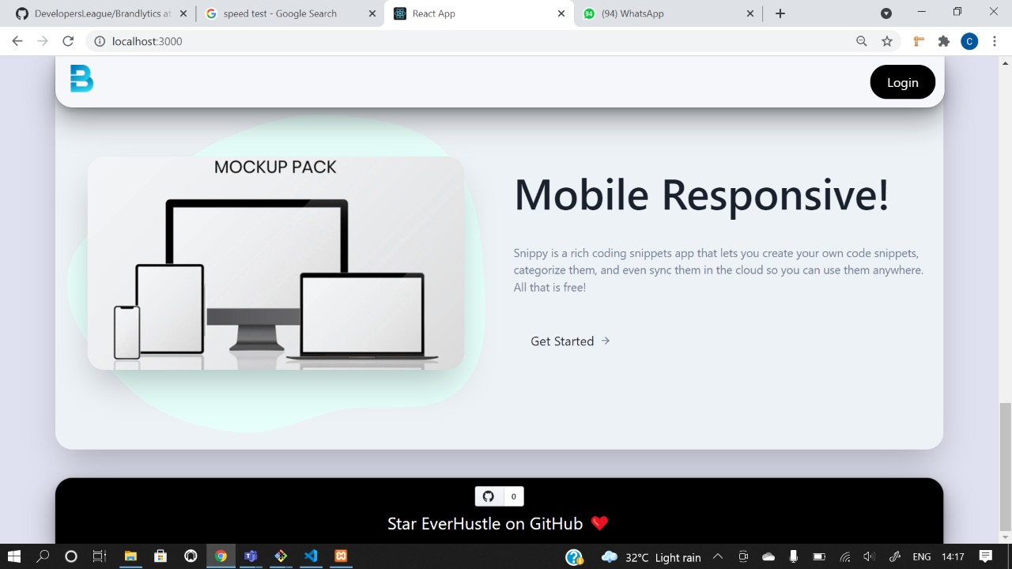

**Fig 3.5.2 Login:** User can log in via registered email id and password

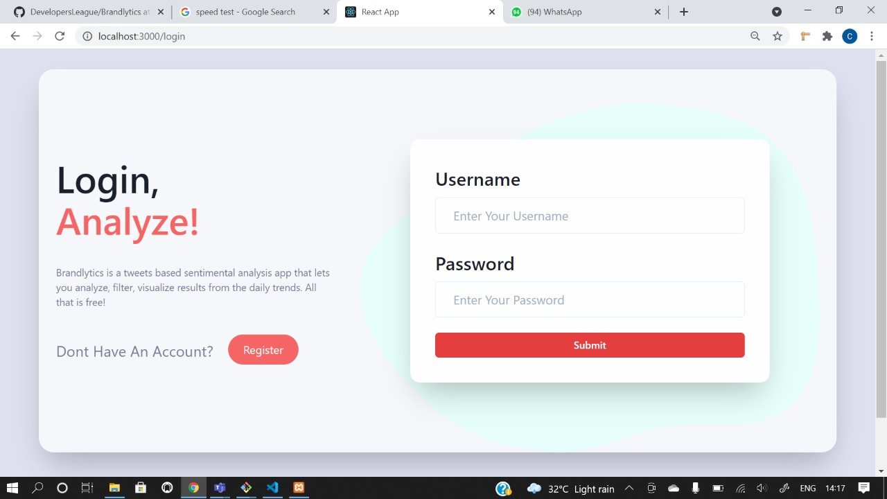

**Fig 3.5.3 Sign up:** For creating an account using first name, last name, email. password

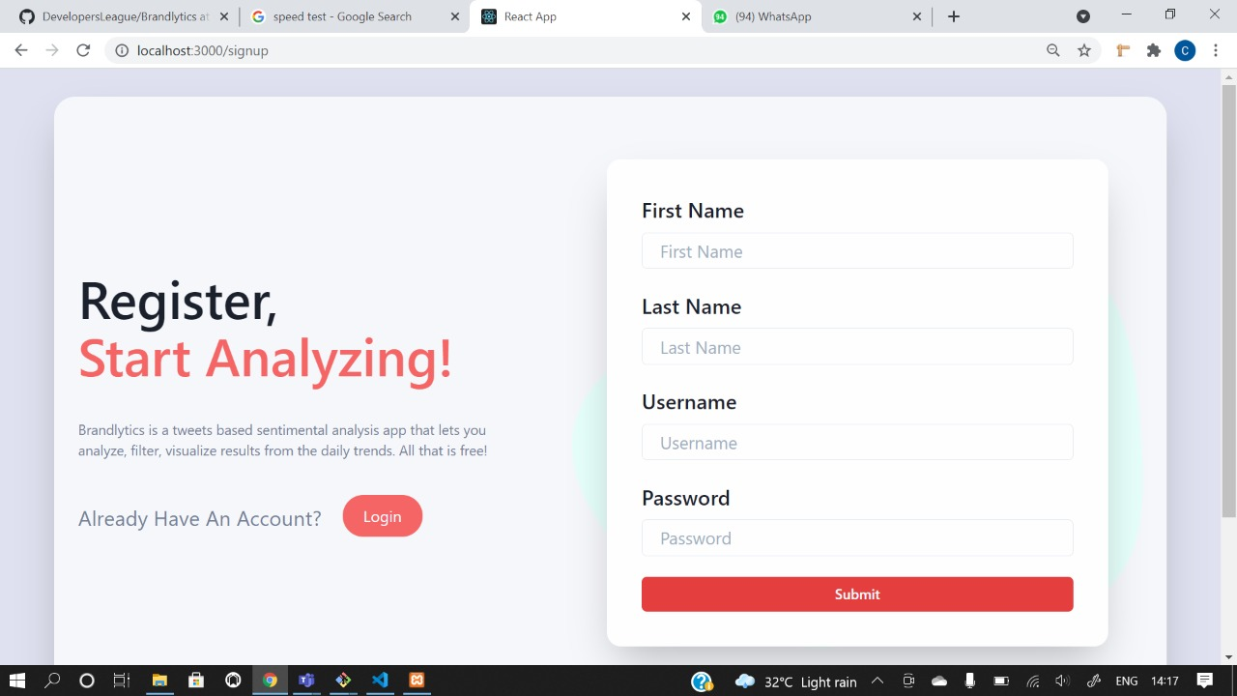

**3.6 Conclusion and future work**

Conclusion: An open-sourced web application is created that will help people in knowing sentiment for a sentence or particular keyword

Future work:

Increase accuracy of model

Can provide sentiment for sentences & words in other languages

**3.7 References**

1. create-react-app( <https://create-react-app.dev/docs/getting-started> )
2. reactstrap( <https://reactstrap.github.io/> )
3. react-router-dom( <https://reactrouter.com/web/guides/quick-start> )
4. react-query( <https://react-query.tanstack.com/> )
5. TypeScript( <https://www.typescriptlang.org/docs/> )
6. [1]( <https://www.talkwalker.com/quick-search> ) visited on 4th October, 2021
7. [2]( <https://www.repustate.com/> ) visited on 4th October, 2021
8. [3]( <https://www.lexalytics.com/ssv> ) visited on 4th October, 2021
9. Datset (<https://www.kaggle.com/kazanova/sentiment140> )